The use of logo is governed by General Terms and Conditions EURO CERTIFICATION DOOEL. (EUROCERT. DOEEL) and General Conditions for the Certification of Management Systems

Name and registered Office of the logo holder

EUROCERT. DOEEL is the holder of the registered trade mark, which can be used in the form shown in this document.

Mark Users

The logo users are the holders of valid EUROCERT. DOEEL certificates, the holders of EUROCERT. DOEEL certificates being those companies whose management system has been certified by EUROCERT. DOEEL. It is not transferable including sites that are not certified.

THE USE OF LOGO IN ADVERTISING AND PUBLICITY
Symbol is issued by Certification Body to be used by Client Certified to indicate their certified status. This applies to symbols that have a specific form including some basic description of its applicability. A statement in words alone does not constitute a symbol in this sense. Any such wording should be true and not mislead.
The display of the said mark/s must be true and must not be misled as a certification of the product.

The symbol/s may then only be used as specified in this document

Dos:
Do use the logo with or without a statement- on business stationery, banners, corporate presentations, videos, brochures, catalogues, vehicles, purchase order, invoice.
Do discontinue usage of logos upon revocation of certification.

RULES FOR THE USE OF THE STATEMENT IN ADVERTISING AND PUBLICITY
Any statement on product packaging is considered as that which can be removed without the product disintegrating or being damaged. A statement in accompanying information is consider as separetly available or easily detachable. The statement shall in no way imply that the product, process or service is certified by this means.
The statement shall include reference to:
- Identification (e.g. brand or name) of the certified client
- The type of management system and the applicable standard (e.g ISO 9001 etc)
- The certification body (EUROCERT. DOEEL for Accreditation Body (AB)) issuing the certificate.

e.g. XYZ Company Ltd has been certified Quality Management System by EUROCERT. DOEEL

DON’ts
Do not use on test reports, calibration results or inspection reports or test certificates related to products.
Do not use to use the Accreditation Body (AB), EUROCERT. DOEEL marks on the product or container or package used, all types of products, including large packaging and product information such as instruction manual.

Do Not use to use the mark Accreditation Body marks in all cases.

LOGO
Example:

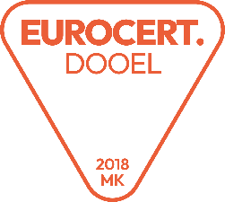 | or | 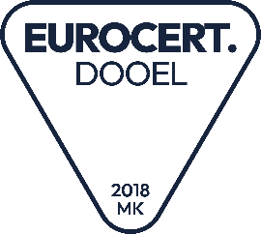 | CERT NO:QMS-389-0000 ISO 9001:2015  CERT NO:EMS-389-0000 ISO 14001:2015
CERT NO:QMS-389-0000 ISO 9001:2015  CERT NO:EMS-389-0000 ISO 14001:2015 | or

